WEEK 5: E-COMMERCE DATABASE MANAGEMENT SYSTEM
Payment Management and Transaction Analysis
1. INTRODUCTION
An E-Commerce Database Management System stores and manages information related to customers, products, orders, payments, and transactions. In Week 4, the
The Payment table stores information such as Payment ID, Order ID, Payment Date, Payment Mode, Payment Status, and Transaction Amount. By connecting payment records with the Orders and Customer tables, the system provides a clear view of customer transactions and order payment details.
2. OBJECTIVES
The main objectives of the Week 5 task are:
- To extend the existing e-commerce database with a Payment Management module.
- To maintain payment details for customer orders.
- To support different payment methods, including UPI, credit cards, debit cards, net banking, and cash on delivery.
- To track payment statuses such as Success, Failed, and Pending.
- To maintain data accuracy using database constraints.
- To update payment information when a transaction status changes.
- To retrieve payment details associated with customers and orders.
- To identify the most frequently used payment methods.
- To calculate successful payment revenue and average transaction amounts.
- To verify payment records and maintain database integrity.
3. DATABASE DESIGN
3.1 Database Name
Ecommerce_Product_DB
The existing database from Week 4 is reused for this task. The Payment table is added to the existing database instead of creating a separate database.
3.2 Payment Table
The Payment table stores the payment information associated with customer orders.
The table contains the following attributes:
Attribute | Description
Payment_ID | Unique identifier for each payment record
Order_ID | Identifies the order associated with the payment
Payment_Date | Date on which the payment record is created or updated
Payment_Mode | Method used to make the payment
Payment_Status | Current status of the payment
Transaction_Amount | Amount associated with the transaction
3.3 Relationship Between Tables
The Payment table is connected to the existing Orders table through the Order_ID attribute.
The Orders table is also associated with the Customer table through the customer identifier.
This relationship allows the system to retrieve payment details along with the corresponding order information and customer details.
The Payment table uses a one-to-one relationship with Orders for the current database design, because each Order_ID is allowed to appear only once in the Payment table.
4. PAYMENT DATA MANAGEMENT
The Payment table contains sample transaction records associated with existing orders.
The sample records represent payments made through different payment methods and demonstrate different transaction statuses.
The payment methods used in the sample data are:
- UPI
- Credit Card
- Debit Card
- Net Banking
- Cash on Delivery
The payment statuses used are:
- Success: The payment transaction has been completed successfully.
- Failed: The payment transaction was unsuccessful.
- Pending: The payment is awaiting confirmation or completion.
The Payment table uses unique payment identifiers and associates each payment record with an order.
5. DATA INTEGRITY AND CONSTRAINTS
Database constraints are used to maintain the accuracy and reliability of payment information.
5.1 Primary Key
The Payment_ID attribute acts as the primary key. It uniquely identifies each payment record and prevents duplicate payment identifiers.
5.2 Foreign Key
The Order_ID attribute acts as a foreign key referencing the Orders table. This ensures that each payment record is associated with an existing order.
5.3 Unique Constraint
The Order_ID attribute is defined as unique in the Payment table. Therefore, the current design allows only one payment record for each order.
5.4 Not Null Constraint
Important payment attributes, including Order_ID, Payment_Date, Payment_Mode, Payment_Status, and Transaction_Amount, must contain values.
This prevents essential payment information from being left empty.
5.5 Default Values
The payment date is assigned the current date by default when no date is provided. The payment status defaults to Pending when a status is not specified.
5.6 Check Constraints
The payment method is restricted to the approved payment options. The payment status is restricted to Success, Failed, or Pending. The transaction amount must be greater than or equal to zero.
These constraints help prevent invalid values from being stored in the database.
6. PAYMENT RETRIEVAL AND STATUS ANALYSIS
Payment retrieval operations are used to examine transaction records and understand the current payment situation.
6.1 Display All Payment Records
All payment records can be retrieved and arranged according to Payment_ID. This provides a complete view of the payment information stored in the database.
6.2 Retrieve Successful Payments
Successful payment records can be displayed in payment-date order. This helps identify completed transactions and review their associated dates and amounts.
6.3 Retrieve Failed and Pending Payments
Failed and pending transactions can be retrieved separately or together. These records help identify payments that may require verification, follow-up, or further processing.
6.4 Count Transactions by Status
Transactions can be grouped according to their payment status. The system calculates the number of transactions under each status.
This analysis helps the business understand how many payments are successful, failed, or still pending.
7. PAYMENT RECORD UPDATION
Payment information may require updates when a transaction status changes.
For example, a pending payment may become successful after confirmation from the payment service. Similarly, a failed transaction may require another attempt or verification.
The update operation changes the payment status, payment method, or payment date for the selected order when the specified conditions are satisfied.
After updating a payment record, the system retrieves the corresponding payment and order details to verify the change.
8. CUSTOMER AND ORDER PAYMENT DETAILS
The Payment Management module supports combined reports using the Customer, Orders, and Payment tables.
8.1 Customer Payment Report
The customer payment report displays the customer's identifier, name, email address, order date, order status, payment date, payment method, payment status, and transaction amount.
This report provides a consolidated view of customer orders and their associated payment details.
8.2 Orders Without Payment Records
A report using a left join can display customer orders even when no corresponding payment record exists.
This helps identify orders that have not yet been associated with a payment record.
It also provides a useful foundation for monitoring incomplete transactions and checking whether payment information has been recorded for each order.
8.3 Failed and Pending Order Report
The system can display orders whose payments are failed or pending. The report includes the order identifier, customer name, order total, payment method, payment status, and transaction amount.
This information helps the business identify transactions that may require attention.
9. PAYMENT METHOD ANALYSIS
Payment method analysis helps understand customer preferences and the distribution of transactions across different payment methods.
9.1 Transaction Count by Payment Method
The system counts the number of transactions made through each payment method and arranges the results from the highest count to the lowest count.
This helps identify which payment methods are used most frequently.
9.2 Most Frequently Used Payment Method
The transaction counts are compared to identify the payment method with the highest number of transactions.
If multiple payment methods have the same highest count, all tied methods can be displayed.
This information can help an e-commerce business prioritize the payment options most commonly used by customers.
9.3 Successful Transactions by Payment Method
The system groups successful transactions by payment method. For each method, it calculates the number of successful transactions and the total revenue associated with them.
This helps compare the contribution of different payment methods to successful payment revenue.
10. REVENUE AND TRANSACTION ANALYSIS
Financial analysis helps the business understand the value of completed transactions.
10.1 Successful Payment Revenue
Successful payment revenue is calculated by adding the transaction amounts of records whose payment status is Success.
Failed and pending transactions are excluded from this calculation.
The result represents the total amount recorded against successful payments in the Payment table.
10.2 Average Transaction Amount
The average transaction amount is calculated using the transaction amounts of all payment records.
The result provides an estimate of the average amount associated with a payment record, regardless of its current status.
This measure helps understand the general transaction value within the available sample data.
10.3 Difference Between Order Amount and Payment Amount
The order total represents the amount associated with an order, whereas the transaction amount represents the amount recorded in the Payment table.
These values may differ because of partial payments, payment attempts, discounts, refunds, or differences in how the sample data was prepared.
In this project, the amounts are used for demonstrating payment analysis. Before using the results for actual accounting, the payment amounts should be reconciled with order totals and verified transaction records.
11. PAYMENT RECORD VERIFICATION
The system performs a verification operation to identify orders associated with more than one payment record.
The verification groups payment records by Order_ID and checks whether any order has multiple records.
Since Order_ID is defined as unique in the Payment table, the expected result is an empty result set.
This confirms that the current table design prevents multiple payment records from being associated with the same order.
However, a production e-commerce system may need to record multiple payment attempts for one order. Such a system would generally use a different design that allows multiple payment records while separately tracking the final payment outcome.
- Outputs
A Payment table is added to the existing e-commerce database.
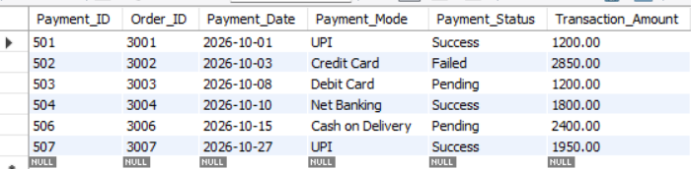
- Payment records are associated with existing orders.
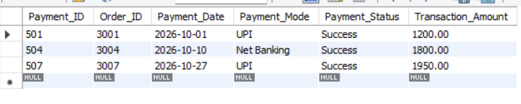
- Payment information is stored using appropriate constraints.
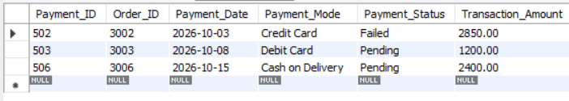
- Successful, failed, and pending transactions can be retrieved.
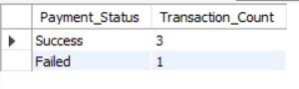
- Customer, order, and payment information can be displayed together.
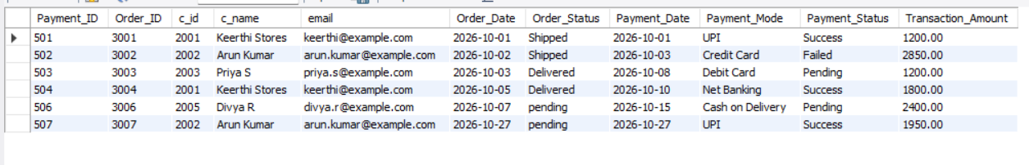
- Transactions can be compared across payment methods.
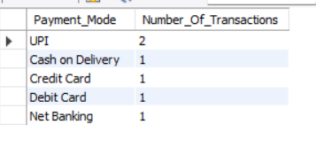
- Successful payment revenue can be calculated. 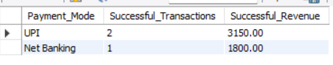

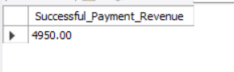
- The average transaction amount can be determined.
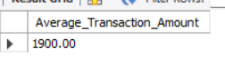
- Payment record consistency can be checked.
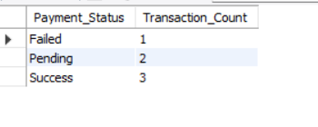
The actual results depend on the records present in the Orders, Customer, and Payment tables.
13. CONCLUSION
Week 5 successfully extends the E-Commerce Database Management System developed in Week 4 by introducing a Payment Management module.
The module organizes payment details, connects payments with existing orders, and applies database constraints to improve data consistency. It supports payment retrieval, status analysis, payment record updates, customer and order reporting, payment method comparisons, and revenue calculations.
The project demonstrates how relational database operations can be used to manage payment information and generate useful business reports. It also provides a foundation for future improvements, such as payment gateway integration, refund management, multiple payment attempts, and automated transaction verification.

